MASTERING SYSTEM DESIGN INTERVIEW
FAANG Data Engineering System Design: Complete Interview Master Guide
For a Data Engineering interview at Google, Amazon, Meta, Apple, or Netflix, you need to demonstrate more than the ability to draw boxes and arrows. You need to explain how data enters a system, how it is processed, how it is stored, how it scales, how failures are handled, and how the business uses the results.
Since you already have experience with SQL, Python, dashboards, ETL/ELT, and analytics, your best approach is to build from familiar data pipelines toward distributed systems, streaming architectures, and large-scale data platforms.
I'll organize this into a practical interview guide with 150 system design projects: 50 easy, 50 medium, and 50 hard, followed by a step-by-step framework for solving them in interviews.
1. First, understand what system design means in Data Engineering
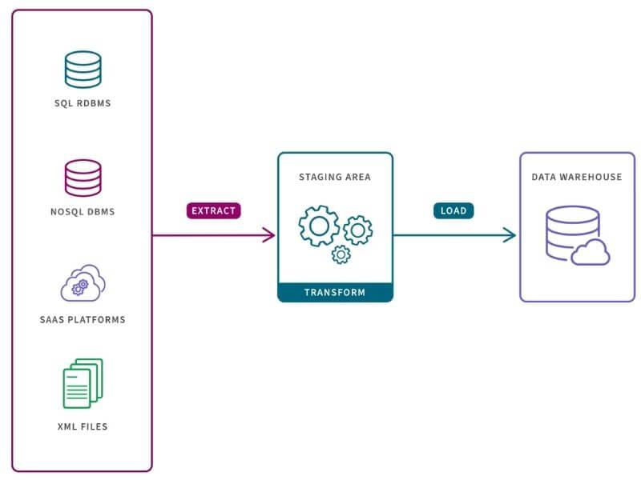
1. Data Engineering system design
Designing systems that collect, transform, validate, store, and deliver reliable data.
Examples: ETL pipelines, data warehouses, CDC, batch processing.
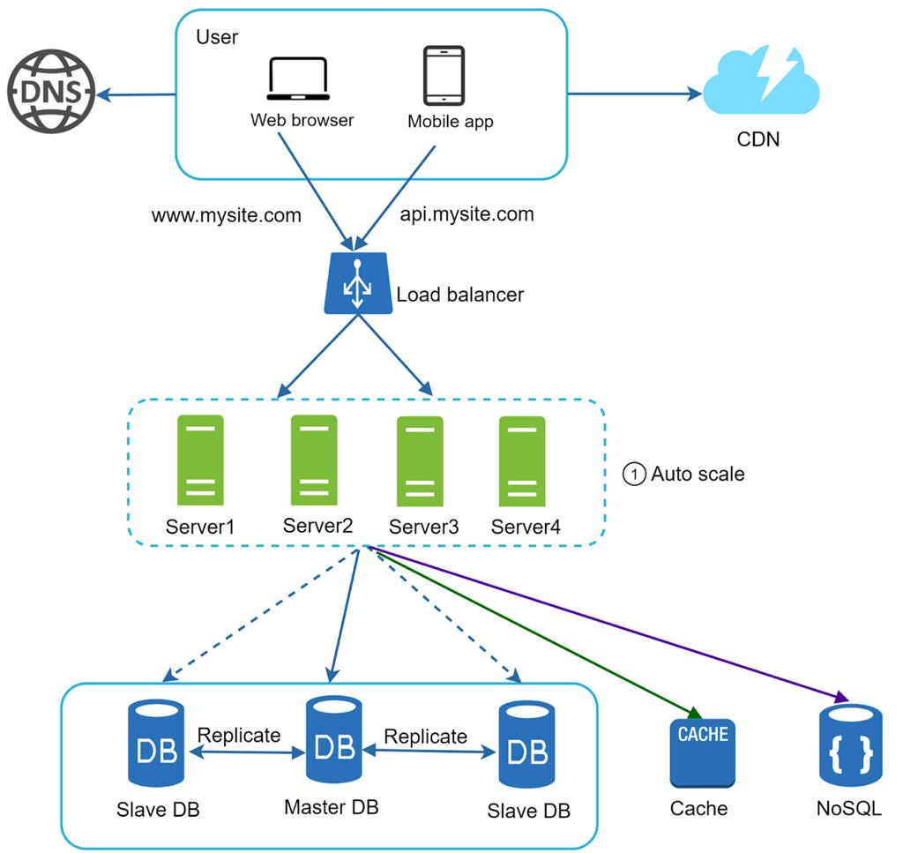
2. High-Level Design (HLD)
The overall architecture and interactions between major components.
Examples: Kafka, object storage, Spark, warehouse, orchestration.
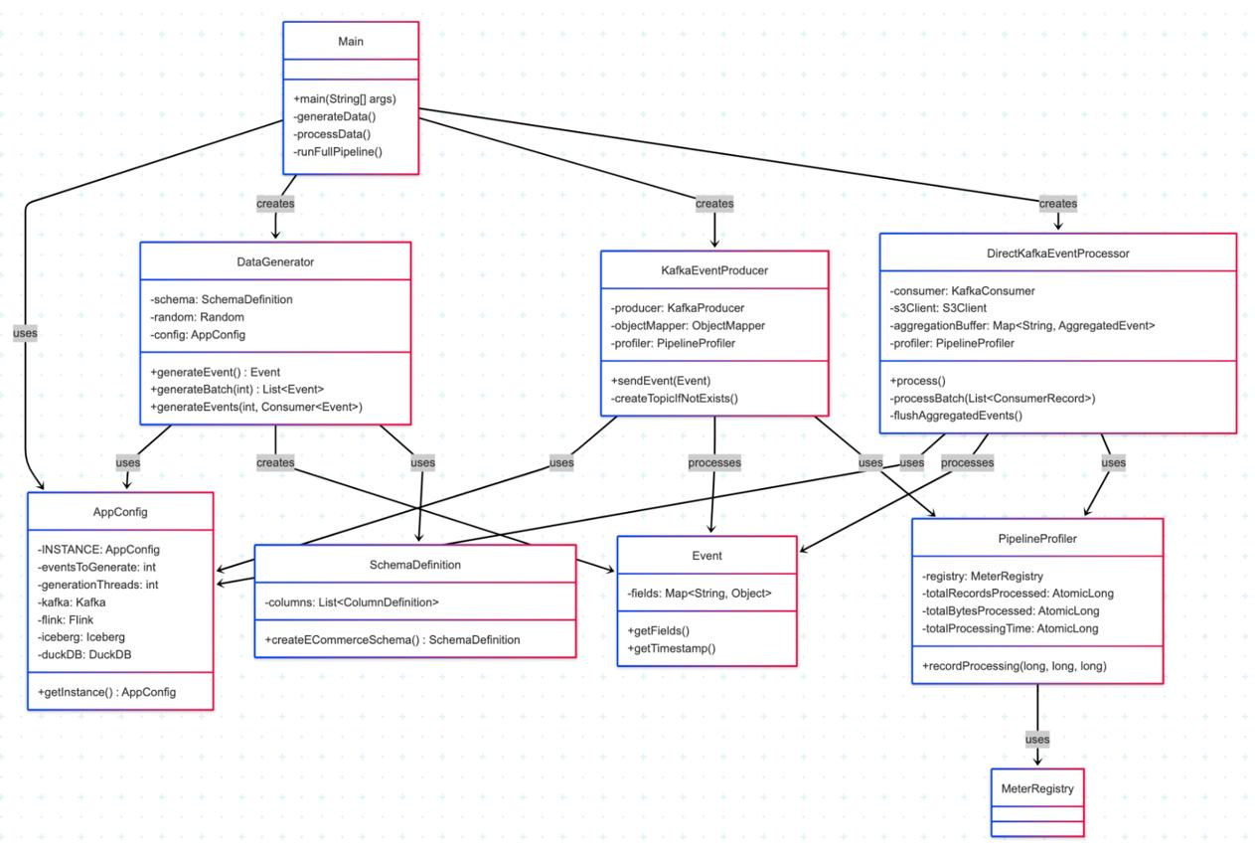
3. Low-Level Design (LLD)
How individual components, classes, interfaces, schemas, and error-handling mechanisms work.
Examples: Python pipeline classes, retry logic, validation modules, configuration.
For a Data Engineering interview, HLD is usually the main focus when the interviewer asks you to design a large data platform. LLD, SQL, Python, and distributed-systems fundamentals can also be tested.
2. What interviewers expect you to explain
Area | Questions you must answer
Requirements | Who uses the data? What business problem are you solving?
Scale | How many records, events, users, and GB/TB per day?
Ingestion | Batch, streaming, APIs, files, or CDC?
Processing | SQL, Python, Spark, Flink, or dbt?
Storage | PostgreSQL, object storage, lakehouse, or warehouse?
Modeling | Fact tables, dimensions, partitions, and schemas?
Reliability | Retries, checkpoints, deduplication, and recovery?
Performance | Partitioning, parallelism, indexing, and query optimization?
Consistency | How fresh must the data be? Can late data change results?
Security | Access controls, encryption, PII, retention, and auditing?
Operations | Monitoring, data quality, lineage, and alerting?
Trade-offs | Why this design instead of another approach?
The key is to explain why each component exists, not just name tools such as Kafka, Spark, or Airflow.
3. The interview framework: how to tackle any system design question
Use this eight-step method for almost every question. A 40–45 minute interview is a useful practice target, although the actual format varies by company and interviewer.
Step 1 — Clarify the requirements (3–5 minutes)
Ask about the users, business purpose, expected output, latency, volume, retention, and reliability requirements.
Example: “Does the dashboard need data every five seconds, every five minutes, or once per day?”
Step 2 — Define functional and non-functional requirements (3 minutes)
Functional: ingest transactions, calculate revenue, expose daily reports.
Non-functional: freshness, availability, correctness, scalability, security, and cost.
Step 3 — Estimate the scale (3–5 minutes)
Estimate events per second, daily data volume, storage growth, concurrent consumers, and retention.
Step 4 — Draw the high-level architecture (5 minutes)
Start with source systems, ingestion, processing, storage, serving, and monitoring. Explain the direction of every data flow.
Step 5 — Design data models and processing (5–8 minutes)
Define the schema, keys, grain, transformations, deduplication, partitions, late-arriving records, and incremental updates.
Step 6 — Handle failures and scale (8–10 minutes)
Explain retries, checkpoints, backfills, replay, idempotency, replication, bottlenecks, and recovery procedures.
Step 7 — Explain monitoring and security (3–5 minutes)
Cover freshness, completeness, schema changes, failed jobs, lag, access controls, PII, and cost monitoring.
Step 8 — Discuss trade-offs (3–5 minutes)
Explain why you selected batch or streaming, a warehouse or lakehouse, and a particular processing or orchestration approach.
The timings are guidelines, not a rigid script. If the interviewer wants to explore one area deeply, adapt.
4. Your reusable Data Engineering architecture
Learn to draw this architecture from memory before specializing it for each project.
1. Data Sources
Applications · OLTP databases · APIs · CSV/JSON · Logs
2. Ingestion
Batch connectors · CDC · Kafka · File ingestion
3. Raw Storage
Object storage · Immutable raw files · Replayable history
4. Processing and Orchestration
Python · SQL/dbt · Spark · Airflow
5. Curated Storage
Parquet · Lakehouse tables · Data warehouse
6. Data Serving
SQL analytics · BI dashboards · APIs · ML features
Cross-cutting layers: data quality · catalog and lineage · access control · observability · cost management · recovery
This is a starting template, not a mandatory architecture. A small daily report might need only SQL, Python, and scheduled jobs. A real-time, high-volume event platform may need Kafka, stream processing, partitioned storage, and separate serving systems.
5. The 150 Data Engineering system design projects
The following are 50 easy, 50 medium, and 50 hard project prompts. Each is a system design exercise, not necessarily a complete implementation assignment. The levels reflect increasing architectural complexity, scale, reliability, and distributed-systems requirements.
Level 1 — Easy: 50 foundational projects
Goal: master ingestion, SQL, modeling, scheduled processing, incremental loads, data quality, and basic architecture.
A. Batch pipelines and ingestion10 projects
1. Daily sales ETL pipeline
Import daily sales CSV files, validate records, transform data, and load a reporting table.
2. Employee data warehouse
Combine HR files and relational tables into a consistent employee analytics model.
3. E-commerce order pipeline
Ingest orders and produce daily order, revenue, and cancellation metrics.
4. Inventory reporting pipeline
Track inventory snapshots and stock changes for reporting.
5. Customer data integration
Combine customer data from several sources using a common customer identifier.
6. API-to-warehouse pipeline
Fetch paginated REST API data, handle failures, and load it into a warehouse.
7. Scheduled database extraction
Extract selected database tables daily without repeatedly copying all historical rows.
8. CSV-to-Parquet conversion
Convert raw CSV datasets into compressed columnar files for analytics.
9. Weather data analytics pipeline
Collect periodic weather readings and prepare historical trend tables.
10. Website log ETL
Parse web server logs and calculate traffic by page and day.
B. Data modeling and reporting10 projects
C. Data quality and incremental processing10 projects
D. Orchestration and serving10 projects
E. Introductory streaming and platform concepts10 projects
What you should know after the easy level
You should be able to explain:
- Full loads versus incremental loads.
- ETL versus ELT.
- Primary keys, foreign keys, fact tables, and dimensions.
- Idempotency and duplicate handling.
- Batch scheduling, retries, and backfills.
- Basic partitioning and file formats.
- Data quality checks and source-to-target reconciliation.
- How to troubleshoot a failed pipeline.
Exit test: Design a daily retail sales pipeline on a whiteboard in 15 minutes, then explain how you would recover if the job failed halfway through.
Level 2 — Medium: 50 projects
Goal: learn distributed processing, event streaming, CDC, lakehouse architecture, scaling, and production reliability.
A. Streaming and real-time analytics10 projects
1. Real-time clickstream analytics
Ingest user events and calculate live traffic, engagement, and conversion metrics.
2. Real-time order tracking
Process order status events and expose current order progress.
3. Payment event analytics
Process payment authorization, settlement, failure, and refund events.
4. Live inventory updates
Keep analytical inventory state current as stock events arrive.
5. Real-time website monitoring
Aggregate request latency, error rates, and traffic by service.
6. Streaming fraud feature pipeline
Generate transaction velocity and behavioral features for fraud detection.
7. Real-time campaign attribution
Join click and conversion events while accounting for delayed conversions.
8. IoT telemetry pipeline
Ingest device readings, validate timestamps, and calculate rolling aggregates.
9. Real-time logistics tracking
Process GPS and shipment events with late and out-of-order records.
10. Live marketplace analytics
Aggregate listing, purchase, and seller events for operational dashboards.
B. Distributed batch processing10 projects
C. CDC, lakehouse, and warehousing10 projects
D. Reliability, operations, and governance10 projects
E. End-to-end analytical products10 projects
What you should know after the medium level
You should be able to discuss:
- Kafka partitions, consumer groups, offsets, and lag.
- Spark shuffles, joins, partitioning, and skew.
- CDC, upserts, deletes, and schema evolution.
- Event time versus processing time, watermarks, and late events.
- Idempotent writes, replay, checkpoints, and recovery.
- Lakehouse tables, snapshots, and incremental processing.
- Workload isolation, data governance, lineage, and observability.
- The difference between exactly-once processing guarantees and exactly-once business effects.
Exit test: Design a streaming order analytics platform that processes duplicate and out-of-order events, survives consumer failures, and produces correct daily revenue.
Level 3 — Hard: 50 advanced projects
Goal: practice principal-level architectural reasoning, multi-region resilience, large-scale distributed data systems, and complex trade-offs. Some of these are appropriate for senior or staff-level interview discussions.
A. Internet-scale streaming platforms10 projects
1. Global clickstream platform
Collect events across continents and provide global and regional analytics.
2. Billions-of-events-per-day pipeline
Design ingestion, partitioning, retention, processing, and serving at extreme volume.
3. Global real-time metrics platform
Compute service and business metrics with low latency across regions.
4. Global payment analytics system
Process financial events with strong auditability, deduplication, and recovery.
5. Large-scale fraud detection data platform
Produce real-time features while controlling state size and processing latency.
6. Global IoT ingestion platform
Handle millions of devices, bursty traffic, intermittent connectivity, and late telemetry.
7. Multi-region Kafka architecture
Design regional ingestion, replication, failover, and duplicate handling.
8. Real-time graph event pipeline
Process relationship changes and deliver analytics over a changing graph.
9. Global event replay service
Replay months of historical events without overwhelming live consumers.
10. Real-time anomaly detection platform
Combine streaming statistics, alert thresholds, and historical baselines.
B. Large-scale storage and compute10 projects
C. Distributed correctness and resilience10 projects
D. Enterprise-scale governance and operations10 projects
E. FAANG-scale product data systems10 projects
What you should know after the hard level
- Distributed-system consistency and failure semantics.
- Partitioning, replication, and regional failover.
- Storage and compute scaling at large volumes.
- Stateful streaming and event-time correctness.
- Workload isolation and resource scheduling.
- Privacy, governance, lineage, and deletion guarantees.
- Cost, latency, availability, and correctness trade-offs.
- How to justify complexity rather than introduce it unnecessarily.
Important: Hard projects are useful for advanced practice, but you do not need to master all 50 before applying to Data Engineer roles. Be exceptionally strong at the fundamentals and several representative medium-level designs first.
6. The 15 projects I recommend prioritizing for FAANG preparation
Rather than trying to implement all 150, master these 15 first. They cover a broad set of reusable interview patterns.
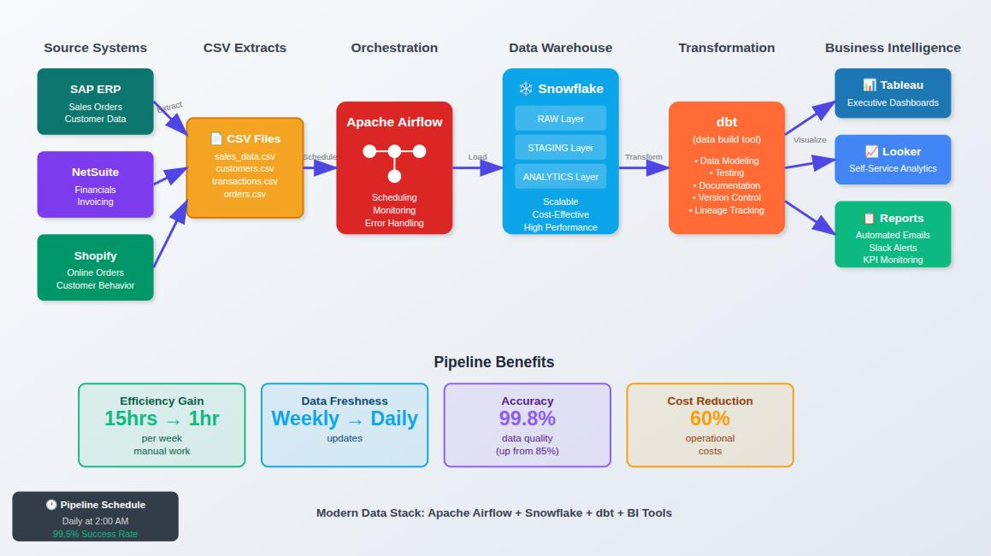
1. Daily sales ETL pipeline
Easy
Learn ingestion, transformations, warehouse modeling, idempotency, and reconciliation.
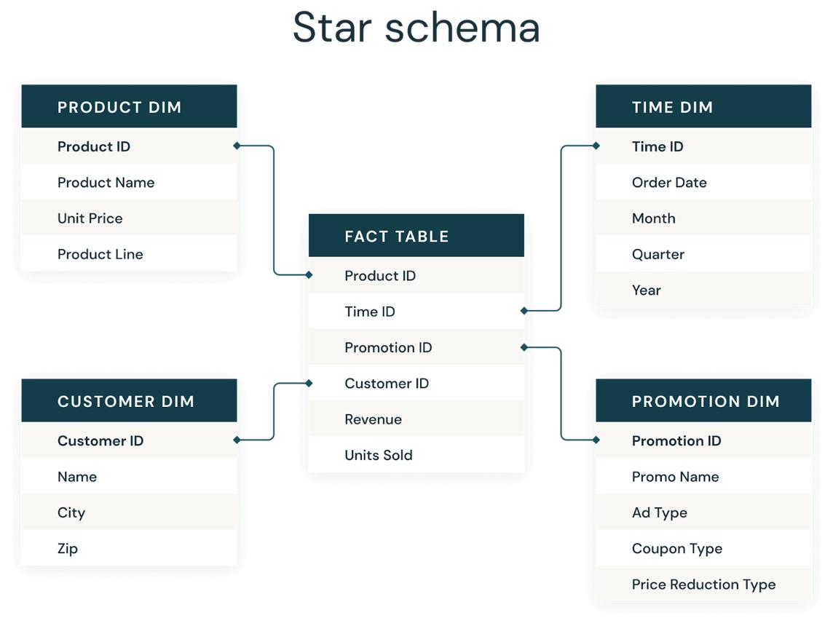
2. Retail sales data warehouse
Easy
Learn fact/dimension design, grain, surrogate keys, SCDs, and query optimization.
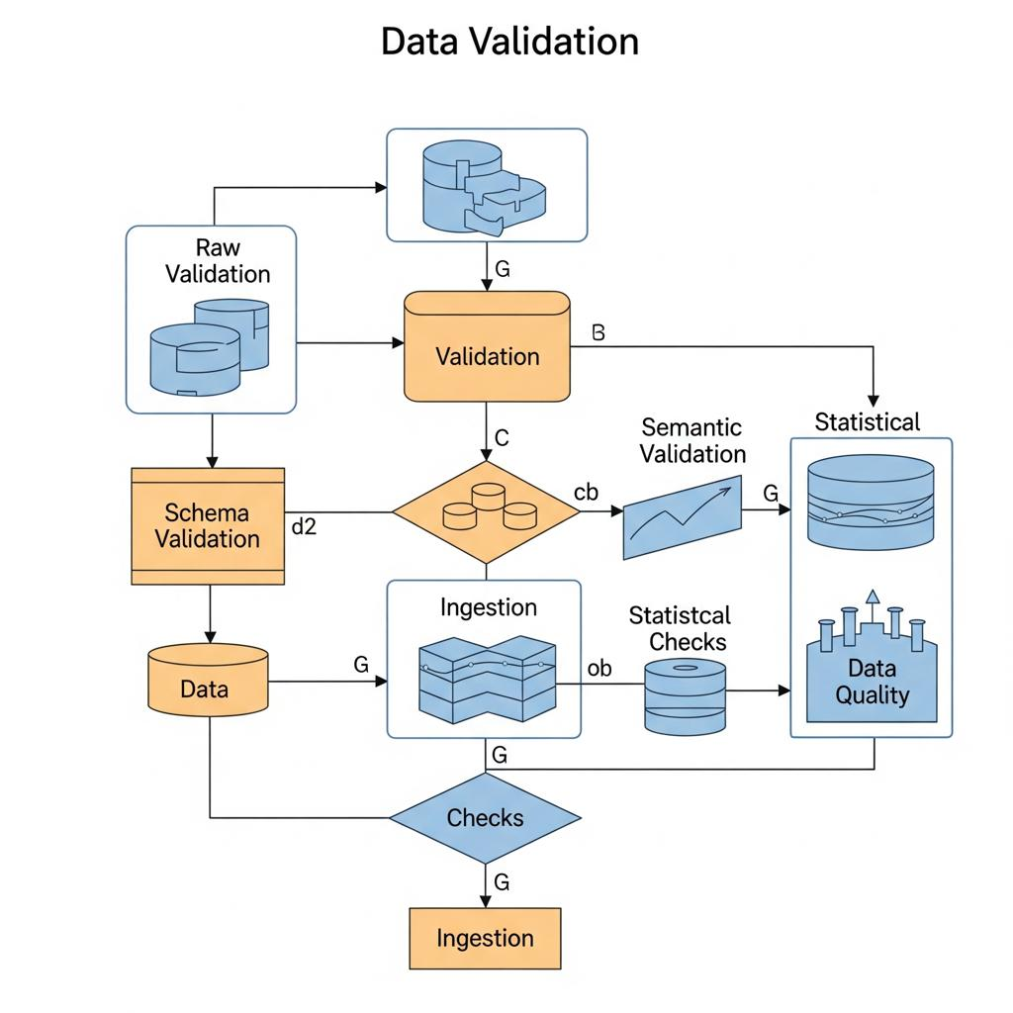
3. Data quality and reconciliation platform
Easy
Learn validation rules, quarantine, data contracts, and alerting.
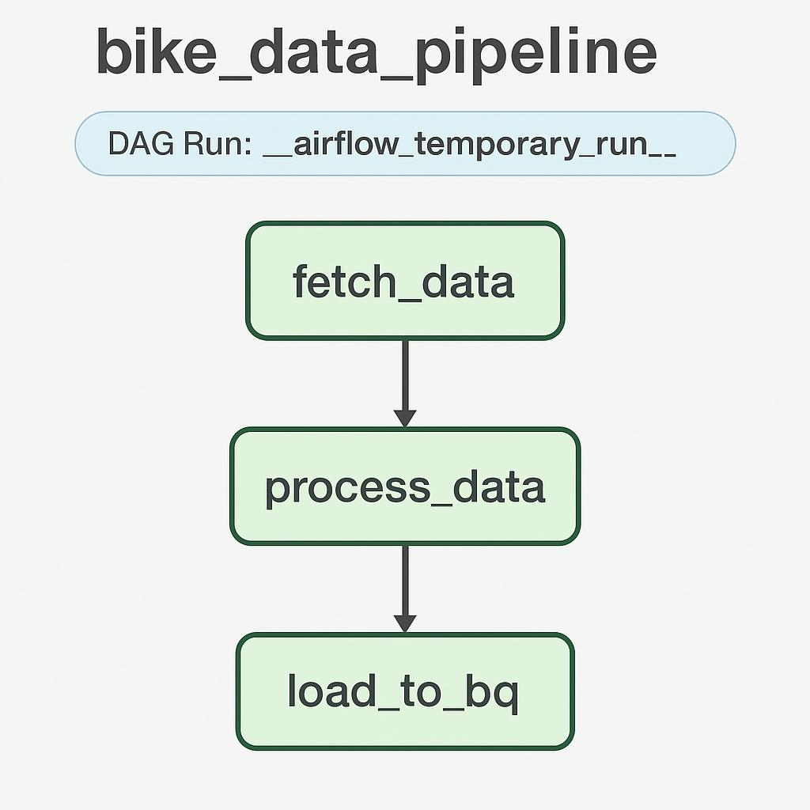
4. Orchestrated incremental ETL
Easy
Learn scheduling, dependencies, retries, checkpoints, and historical backfills.
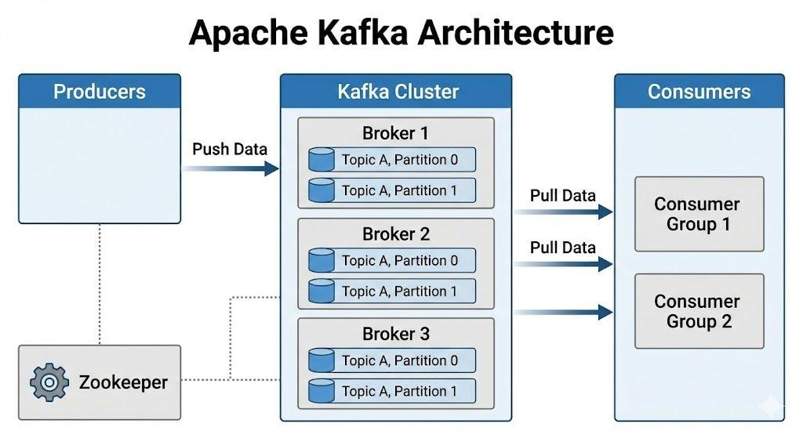
5. Kafka-to-warehouse streaming pipeline
Medium
Learn partitions, offsets, consumer groups, delivery semantics, and lag.
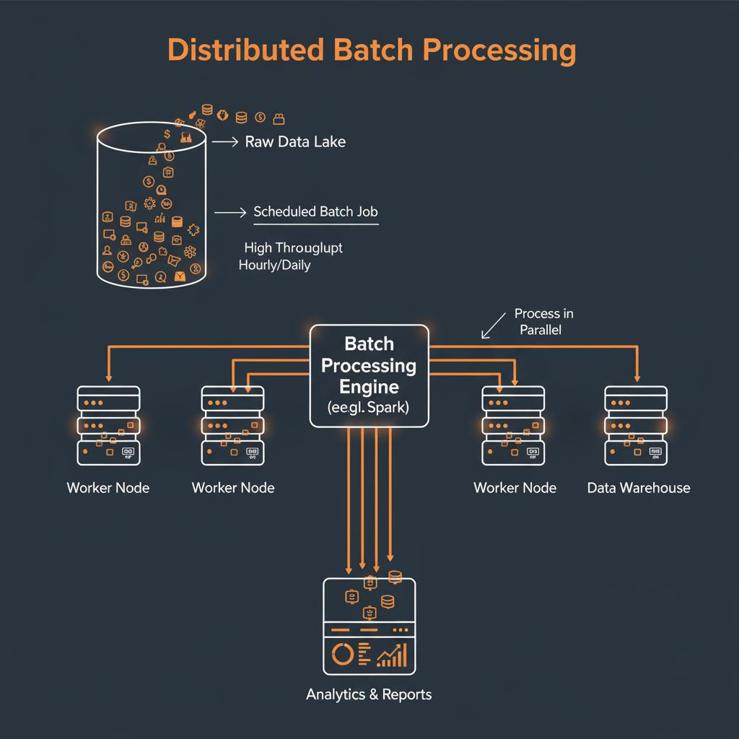
6. Large-scale Spark ETL
Medium
Learn distributed joins, shuffles, skew, partition sizing, and parallelism.
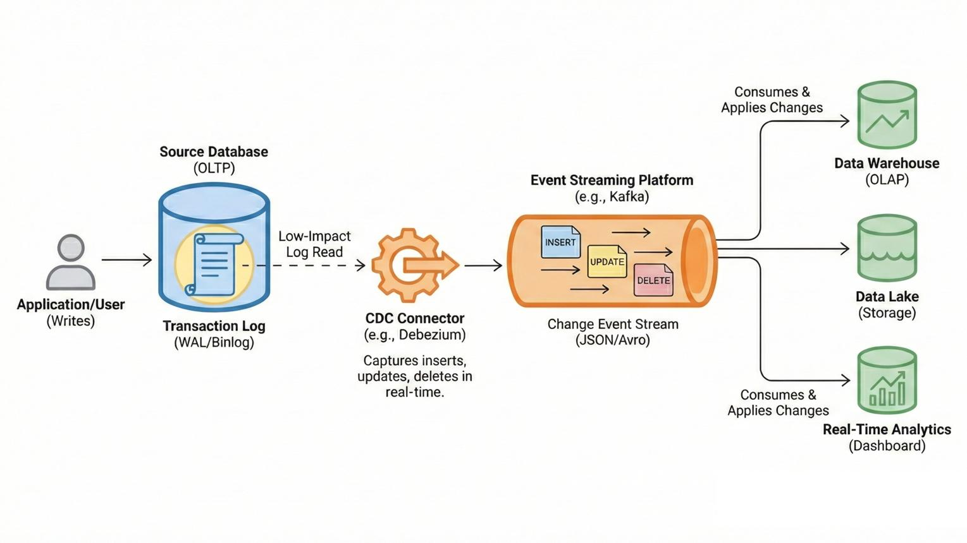
7. CDC-to-lakehouse pipeline
Medium
Learn change logs, inserts, updates, deletes, upserts, and replication lag.
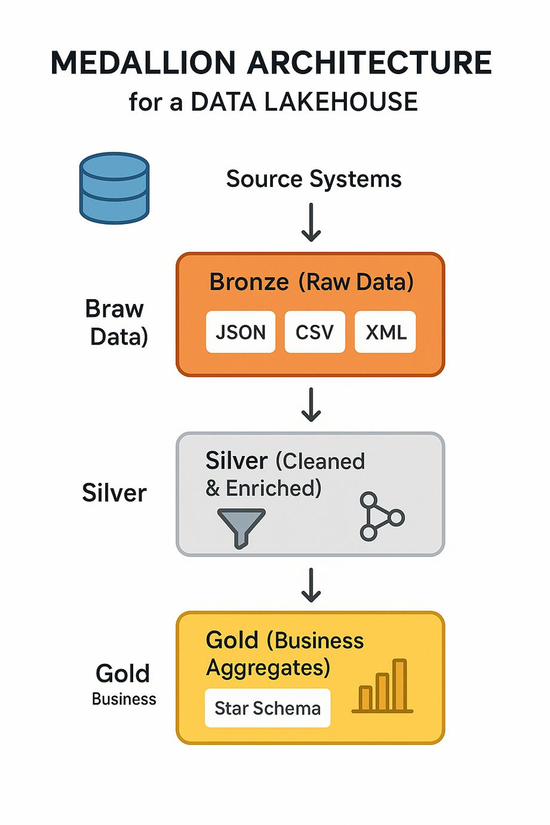
8. Bronze–Silver–Gold lakehouse
Medium
Learn raw versus curated data, replayability, incremental models, and storage formats.
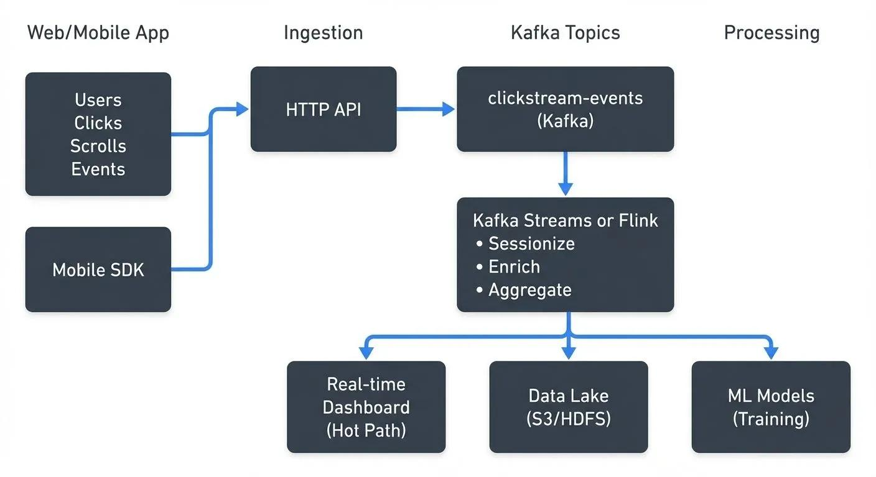
9. Real-time clickstream analytics
Medium
Learn event time, processing time, windows, watermarks, and late events.
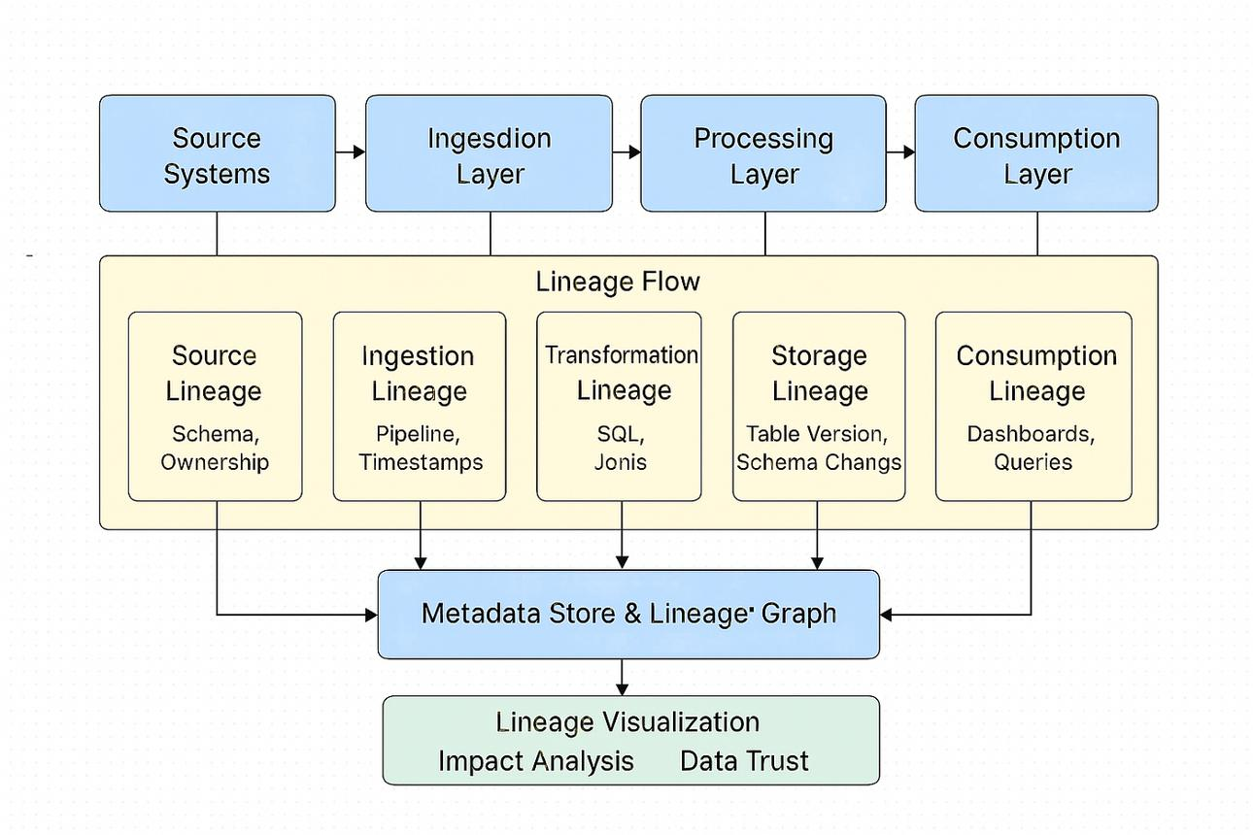
10. Data observability platform
Medium
Learn freshness SLAs, lineage, schema drift, anomaly detection, and incident response.
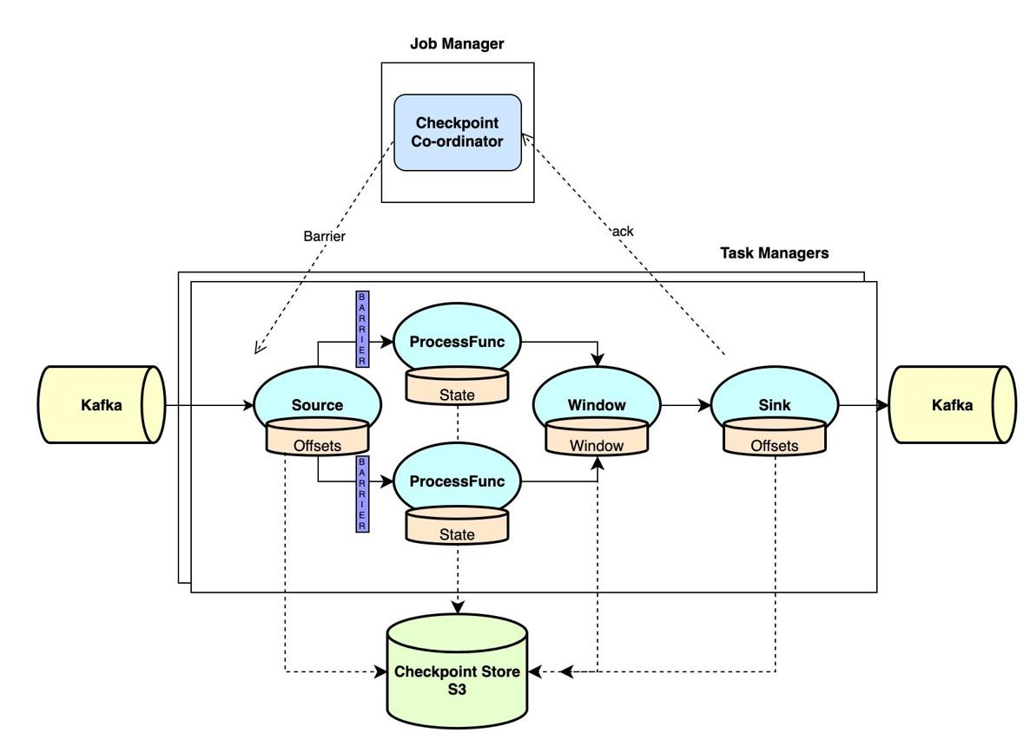
11. Replay-safe streaming aggregation
Medium
Learn idempotent sinks, event deduplication, recovery, and exactly-once limitations.
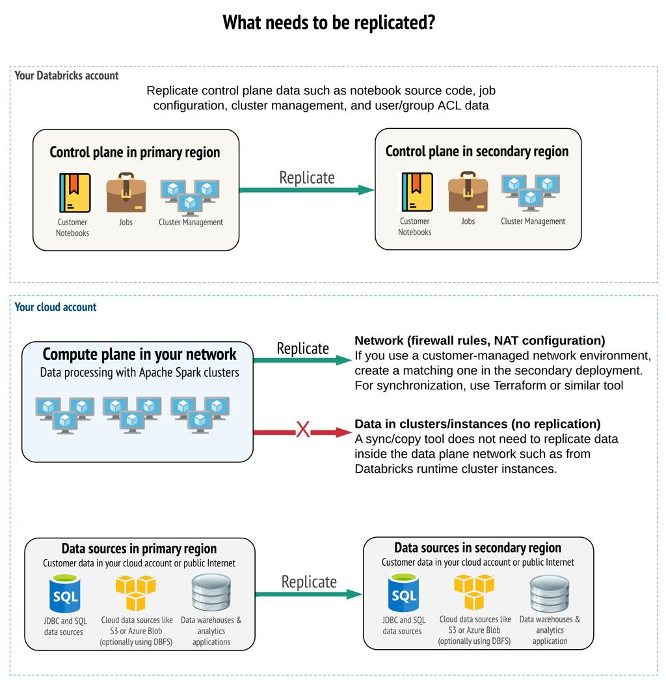
12. Multi-region disaster recovery
Hard
Learn replication, RTO, RPO, failover, and recovery testing.
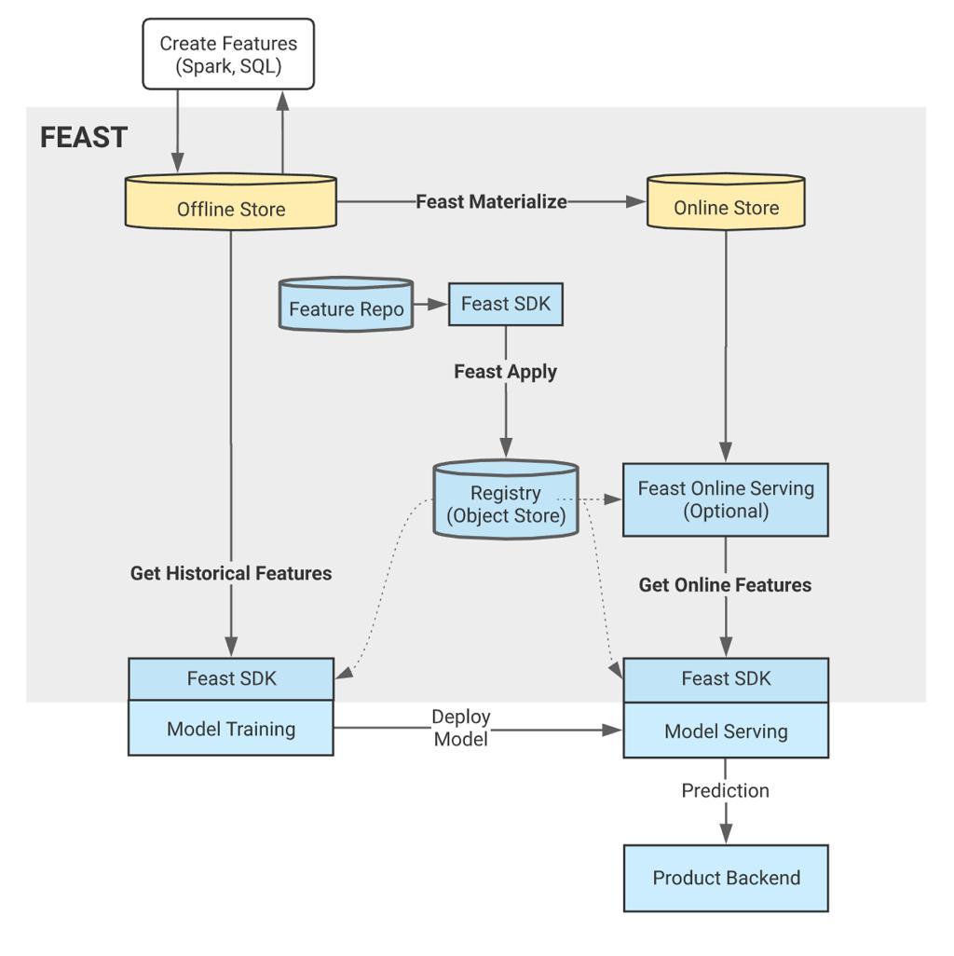
13. Online/offline feature store
Hard
Learn feature freshness, training-serving consistency, point-in-time correctness, and online serving.
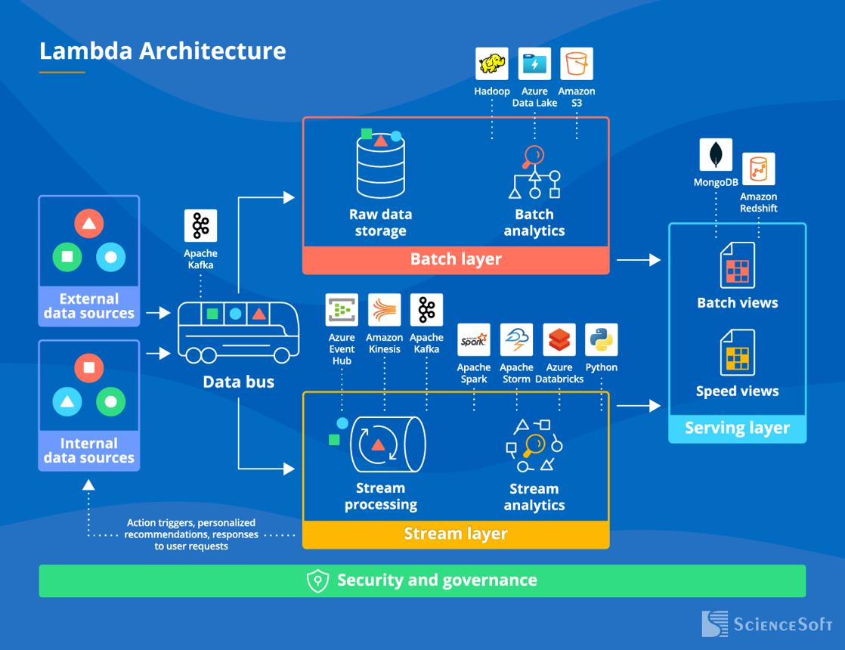
14. Unified batch and streaming platform
Hard
Learn historical recomputation, streaming updates, consistent metrics, and replay.
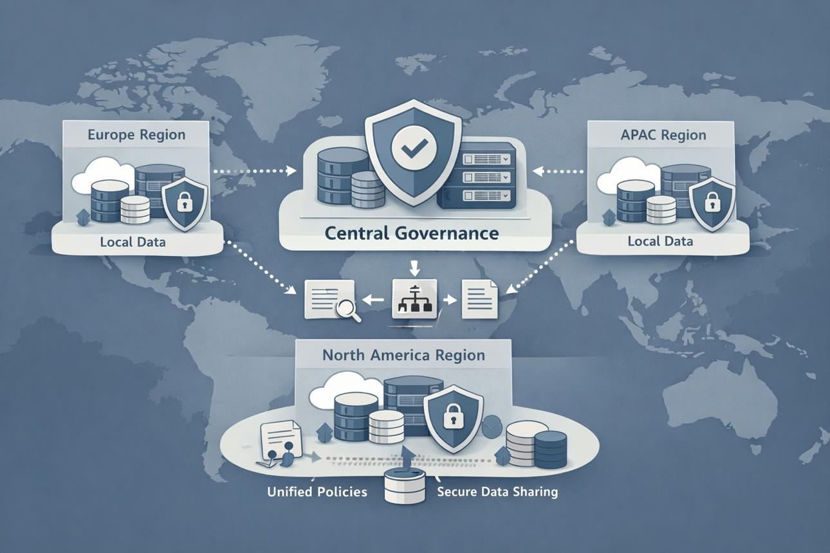
15. Global end-to-end data platform
Hard
Integrate ingestion, processing, storage, serving, governance, security, and recovery.
The retail and sales examples are particularly useful for you because they connect directly to analytics, SQL, dashboards, and your retail price-comparison project.
7. A complete worked interview example
Let's work through a realistic question.
Interviewer: “Design a data platform for an e-commerce company that processes 100 million orders and related events per day and provides near-real-time dashboards.”
Step 1 — Clarify requirements
I would ask:
- Does the business need second-level, minute-level, or hourly freshness?
- Which metrics are needed: revenue, order counts, cancellations, refunds, inventory, or customer activity?
- How long must raw and aggregated data be retained?
- Must the system support historical backfills and corrections?
- What availability and recovery objectives are required?
Assume the interviewer specifies near-real-time dashboards, a multi-year history, and recovery after processing failures.
Step 2 — Estimate the scale
Assume 100 million events per day, with an average serialized event size of 1 KB.
\[ \text{Average events/sec} = \frac{100{,}000{,}000}{86{,}400} \approx 1{,}157 \]
Assume peak traffic reaches 10 times the average.
\[ \text{Peak events/sec} \approx 11{,}570 \]
Raw data volume per day:
\[ 100{,}000{,}000 \times 1\text{ KB} \approx 100\text{ GB/day} \]
This is approximately 36.5 TB per year before compression, replication, indexes, and other storage overhead.
These are illustrative assumptions, not a final capacity plan. Actual throughput depends on event size, burstiness, event types, and the ingestion pattern.
Step 3 — Draw the architecture
Order, payment, inventory, and customer systems
CDC connectors + Kafka
Partitioned events · Replication · Consumer groups
Streaming path
Stream processor
Recent aggregates and alerts
Raw archive
Object storage
Immutable history in Parquet or raw event format
Curated analytical processing
Spark / SQL / dbt · Deduplication · Reconciliation · Historical backfills
Analytical warehouse or lakehouse
Partitioned facts · Dimensions · Aggregates · Historical corrections
BI dashboards and analytical consumers
Revenue · Orders · Refunds · Inventory · Customer metrics
Airflow or another orchestrator manages batch dependencies and backfills. Monitoring, data quality, access control, and lineage span all layers.
A strong explanation would distinguish the streaming path, which serves fresh metrics, from the durable historical processing path, which supports complete recomputation and reconciliation. They can share the event source without being forced into one processing model.
Step 4 — Define the data model
For example:
Fact table: fact_orders
Column | Purpose
order_id | Business identifier for an order
customer_id | Customer dimension key
order_timestamp | When the order was placed
order_status | Current or versioned status, depending on the model
gross_amount | Order value before adjustments
discount_amount | Applied discounts
net_amount | Defined net order amount
updated_at | Source update timestamp
You would also consider separate fact_payments, fact_refunds, and fact_order_items tables. This avoids confusing orders with payment transactions and item-level revenue.
A key interview detail: define the grain before designing the table. One row per order is not the same as one row per order item or one row per payment event.
Step 5 — Explain failure handling
Failure | Design response
Duplicate event | Use stable event identifiers and idempotent processing.
Consumer crash | Resume from committed offsets or checkpoints, subject to the processor's recovery guarantees.
Late-arriving order update | Apply event-time policies and update affected aggregates.
Corrupted input | Quarantine the record and alert the data owner.
Warehouse outage | Buffer upstream data where capacity permits; retry writes safely.
Incorrect historical calculation | Replay source history and rebuild affected partitions.
Source schema change | Validate schema compatibility and coordinate migrations.
Regional outage | Recover according to the defined RTO/RPO and replication strategy.
Do not simply say “Kafka guarantees exactly once.” Explain the boundary of the guarantee. End-to-end correctness depends on source behavior, processing state, transaction support, and the destination's write semantics.
Step 6 — Discuss scaling and trade-offs
- Partition Kafka topics using a key that supports the required ordering and workload distribution.
- Monitor partition skew and hot keys.
- Partition historical analytical data by appropriate time and business dimensions.
- Use columnar storage and compression for analytical workloads.
- Pre-aggregate common dashboard metrics when query latency requires it.
- Isolate backfills from real-time workloads to prevent historical jobs from delaying live metrics.
- Set retention based on replay requirements, compliance, and storage cost.
- Measure end-to-end freshness, not just individual job runtimes.
This is what turns a diagram into an interview-quality design.
8. Essential concepts you must master
Use this checklist while preparing. You should be able to explain each item in simple language, provide a real example, and discuss at least one trade-off.
Architecture and requirements (7)
Functional vs non-functional requirements
Capacity estimation and peak traffic
HLD vs LLD
Batch vs streaming vs micro-batch
Latency vs throughput
Availability vs consistency
SLA, SLO, RTO, and RPO
Storage and data modeling (8)
Distributed systems (8)
ETL and data processing (9)
Streaming and messaging (8)
Production operations (8)
9. A 24-week preparation roadmap
A 6-month plan is a realistic way to develop your skills alongside work. You do not need to implement 150 projects. The objective is to become comfortable designing many systems from a smaller set of reusable patterns.
Weeks 1–4
Foundation and easy systems
Requirements gathering, architecture diagrams, capacity estimation, SQL modeling, ETL/ELT, incremental loads, Python testing, and idempotency.
Deliverable: 4–6 easy designs and one working local batch pipeline.
Weeks 5–8
Warehousing and orchestration
Dimensional modeling, SCDs, partitioning, Airflow, dbt, data quality, schema evolution, and backfills.
Deliverable: a warehouse with scheduled, tested, monitored transformations.
Weeks 9–12
Distributed processing
Spark, shuffles, distributed joins, skew, file sizing, execution plans, and resource management.
Deliverable: a distributed ETL design plus a small working Spark project.
Weeks 13–16
Streaming and CDC
Kafka, event time, windows, late data, offsets, delivery semantics, CDC, and replay.
Deliverable: an event pipeline with deduplication, recovery, and analytical outputs.
Weeks 17–20
Reliability and advanced design
Replication, disaster recovery, observability, security, privacy, cost, workload isolation, and failure analysis.
Deliverable: 4 medium designs and 2 advanced designs with explicit trade-offs.
Weeks 21–24
Interview simulation
Timed whiteboard designs, verbal explanations, SQL and Python practice, failure scenarios, and mock interviews.
Deliverable: 10–15 polished designs, including 3–5 end-to-end flagship systems.
A study routine that fits a working schedule
If you have roughly 60–90 minutes available in the evening:
- 20 minutes: study one concept.
- 25 minutes: draw an architecture or solve a related problem.
- 20 minutes: explain your design aloud without notes.
- 10 minutes: record gaps and revise them the next day.
On weekends, use a longer session to build or extend one project. A smaller, well-explained project is more valuable than many incomplete repositories.
10. Free learning and practice resources
These are useful starting points for your preparation.
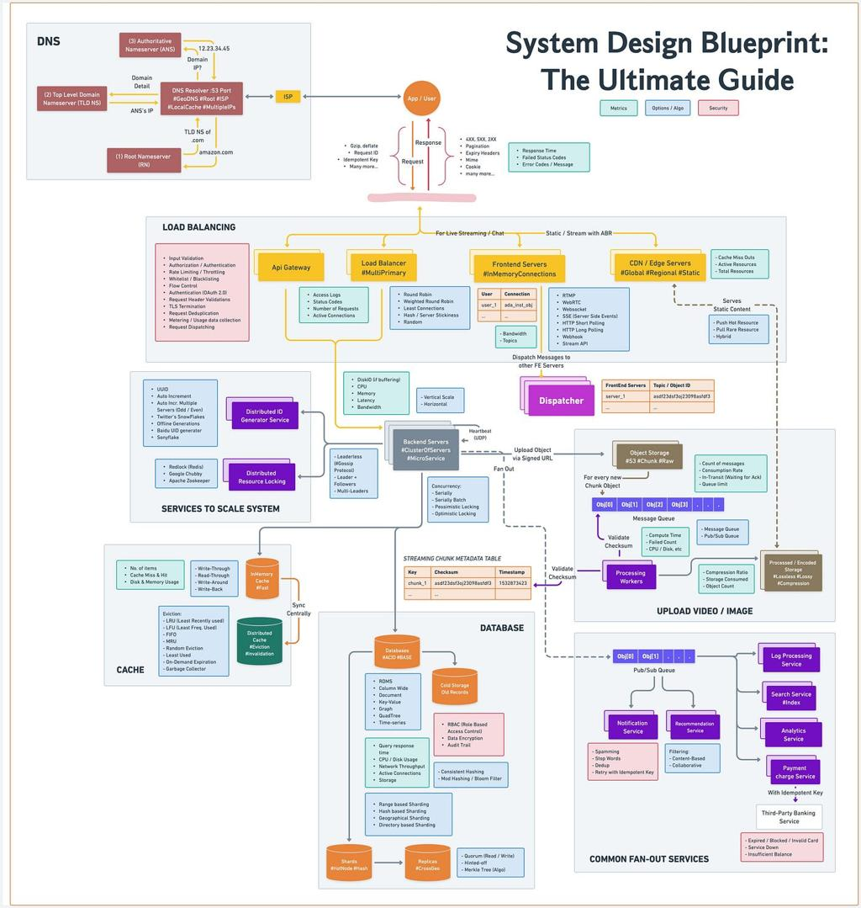
System Design Primer
Distributed systems, caching, databases, scalability, and general interview patterns.
Open GitHub repository
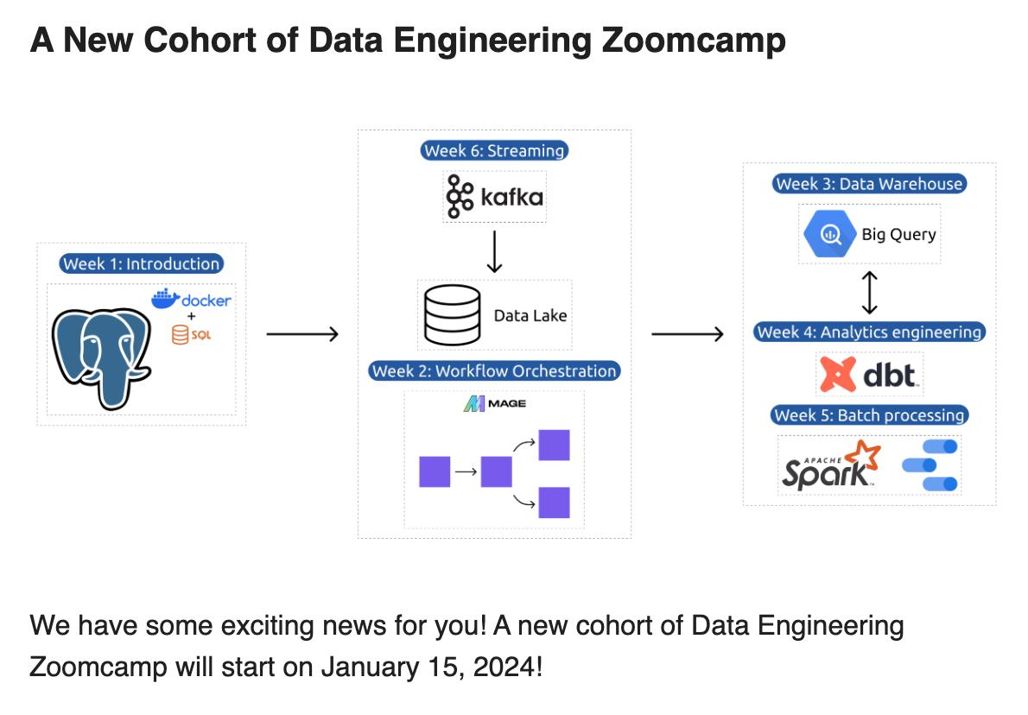
Data Engineering Zoomcamp
Practical data pipelines, orchestration, warehousing, Spark, and related tooling.
Open free course repository
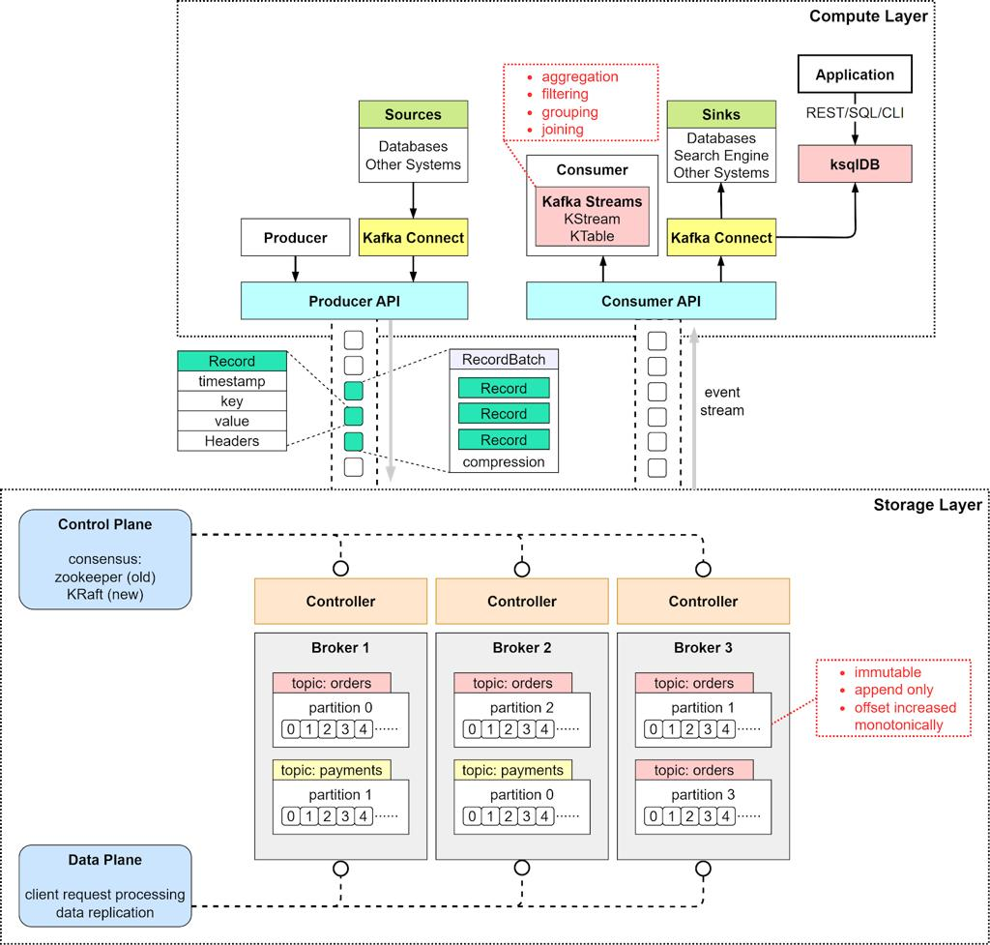
Apache Kafka documentation
Messaging, partitioning, replication, consumer groups, and delivery semantics.
Read the documentation

Apache Spark documentation
DataFrames, SQL, distributed execution, streaming, and performance tuning.
Read the documentation
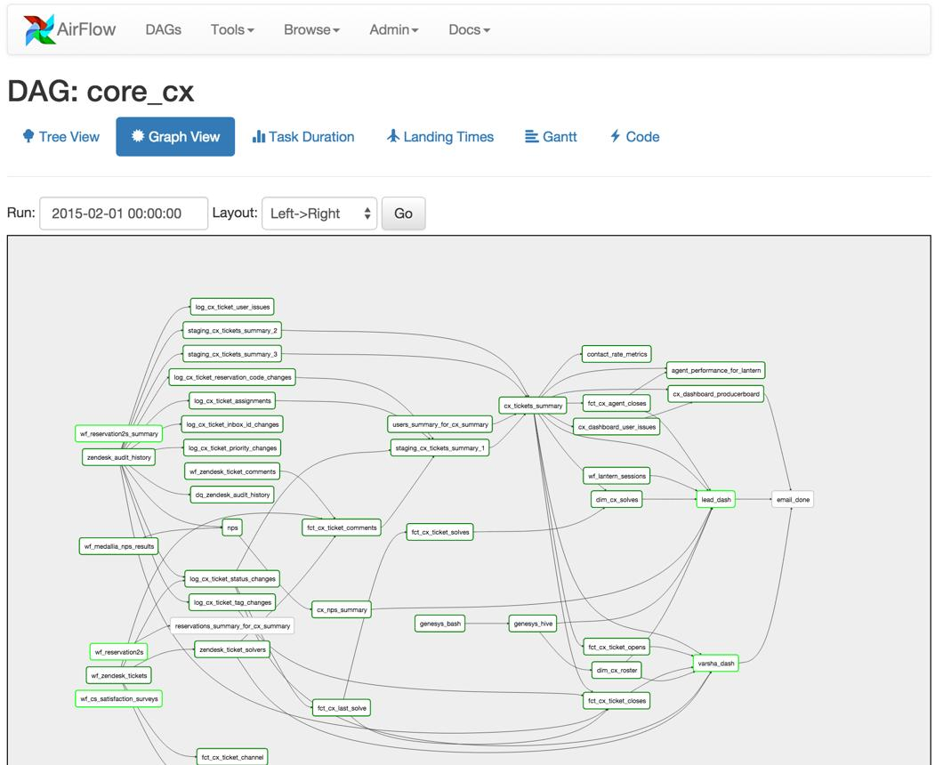
Apache Airflow documentation
DAGs, task dependencies, scheduling, retries, and orchestration.
Read the documentation

SQL interview practice
Practice joins, aggregations, CTEs, window functions, ranking, and analytical queries.
Open SQL problems
Use the official documentation to understand behavior and limitations rather than memorizing architecture diagrams from tutorials.
11. How to communicate clearly during the interview
Use this verbal structure whenever you introduce a component:
Problem → Decision → Reason → Trade-off → Failure handling.
For example, instead of saying:
“I'll use Kafka and Spark for the pipeline.”
Say:
“The source generates order events continuously, so I need a durable ingestion layer that can absorb bursts and allow independent consumers. I'll use Kafka with multiple partitions so consumers can process events in parallel. I'll choose the partition key based on the ordering requirements and expected key distribution. The trade-off is that ordering is generally limited to a partition, and a poorly chosen key can create hot partitions. I'll monitor consumer lag and provide a replay mechanism so processing can recover after failures.”
That answer demonstrates requirements reasoning, architecture, scaling, limitations, and reliability.
Questions to ask yourself after every design
- What is the source of truth?
- What happens if the same record arrives twice?
- What happens if a job fails halfway through?
- How do I correct historical data?
- What happens when traffic grows 10 times?
- What if the data schema changes?
- How do I know the output is correct?
- What if the warehouse or downstream service becomes unavailable?
- How do I control cost and sensitive-data access?
- Why is this architecture better than a simpler alternative?
If you can answer all ten coherently, you are developing the reasoning expected in a strong Data Engineering system design interview.
12. Let's tailor the preparation plan to your target interview
The best next step is to turn this catalogue into a structured practice plan with architecture diagrams, capacity-estimation examples, data schemas, failure scenarios, and model interview answers for each selected project.
Answer a few optional questions so the project order and mock interviews match your target role and current preparation level.
Answer 3 questions
My recommendation is to begin with the daily sales ETL pipeline, then the retail data warehouse, then incremental ETL and data quality, followed by Kafka streaming, Spark processing, and CDC-to-lakehouse design. Once you can explain those systems clearly, many harder interview questions become variations of the same foundational patterns.

